**PROJECT-NAME: SPARKLE MAKEOVER**

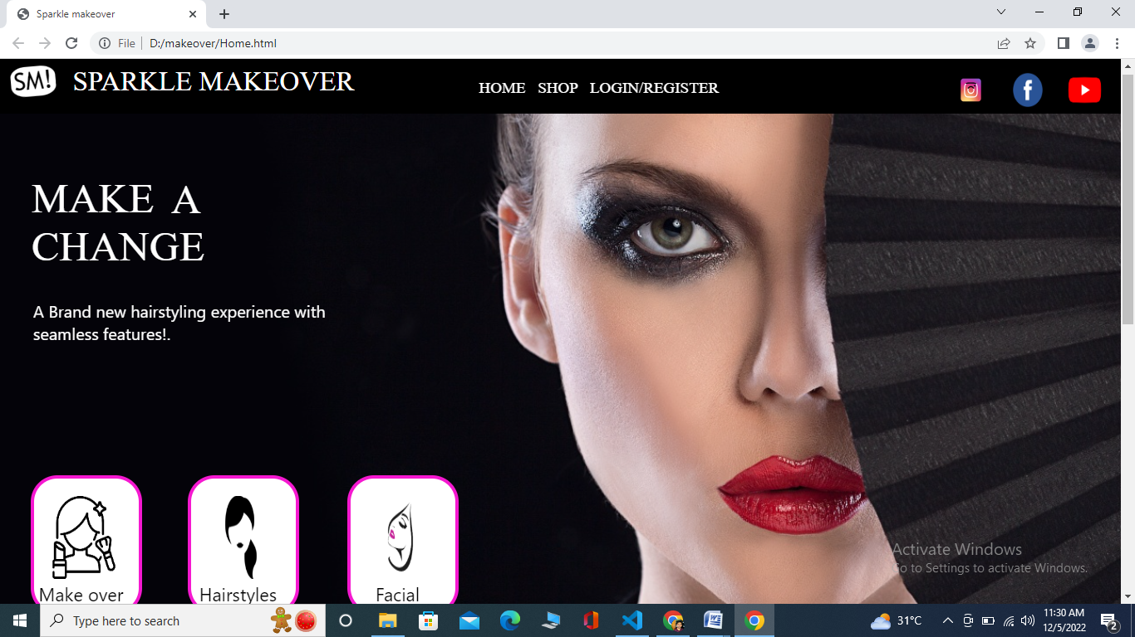

**\*OVERVIEW:**It’s an makeover website for ladies beauty,

from facial to wax everything is available

in this website.

1. **HOME PAGE:**

# LOGO

# ICONS - (facebook,instagram,youtube)

# Login/registration,Home,Shop

# BACKGROUND IMAGE

# OUR SERVICES - (IMAGES)

# COLLECTIONS-(IMAGES)

# FOOTER –(CONTACT US , BRIEF DESCRIPTION

ABOUT OUR WEBSITE , SOCIAL-MEDIA HANDLE

ICONS , LINK TO MOBILE APP)

1. **REGISTRATION FORM:**

# E-MAIL ADDRESS

#PASSWORD

# D.O.B

**3. MAIN PAGE:**

# FILTERS -( BRANDS , COLOR , DISCOUNT RANGE , PRICE

COUNTRY OF ORIGIN ,MATERIAL, FEATURES , SIZE ,TYPE SORT BY: )

# IMAGES OF THE CHOSEN PRODUCT WITH DETAILS LIKE -

(BRAND , PRODUCT NAME , PRICE , DISCOUNT%(IF

ANY))

# ON CLICKING THE IMAGE -(MAIN PAGE GOES TO PAYMENT PAGE FOR PAYMENT.)

# PRODUCT DESCRIPTION - BRAND , PRODUCT NAME ,

PRICE , DISCOUNT%(IF ANY) , SIZE CHART ,

DELIVERY OPTIONS , PRODUCT

DETAILS , SIZE & FIT , MATERIAL & CARE ,

SPECIFICATIONS , CUSTOMER REVIEWS

WITH IMAGES(IF ANY )

1. **PAYMENT PAGE:**

# PAYMENT METHOD - (PHONEPE , GOOGLE PAY , BHIM UPI ,

COD , CREDIT/DEBIT CARD , NET –BANKING,EMI,PAYTM)